**Introduction**

The average total cost of a competitive senate race has nearly quadrupled since 2004 (citation [here](https://www.opensecrets.org/overview/topraces.php?cycle=2004&display=currcandsout) and [here](https://www.opensecrets.org/overview/topraces.php?cycle=2016&display=currcandsout)). During that year, one of the most expensive senate races took place in Pennsylvania. Arlen Specter’s Republican campaign spent $21.9 million dollars on his re-election effort while also enjoying $117 thousand dollars in assistance from four outside groups. Over half of the outside assistance came from a political action committee (PAC) called the NRA Political Victory Fund [(FEC citation here](https://www.fec.gov/data/candidate/S6PA00100/?cycle=2004&election_full=true&tab=other-spending)). This total sum was enough to propel him through a bitter primary challenge against a more conservative Republican named Patrick (“Pat”) Toomey and the general election.

By 2009, Specter felt like he no longer recognized his place in the Republican Party and he chose to switch his affiliation. He ran for re-election in 2010 as a Democrat but failed to emerge from the primary. Pat Toomey ultimately won the senate seat in 2010 and stood for re-election in 2016. Once again, the Pennsylvania senate election was one of the most expensive in the nation. Toomey’s campaign spent $31.5 million dollars and, in stark contrast to the 2004 race, enjoyed $48.2 million dollars in assistance from twenty-six outside groups spending in support of his candidacy and in opposition to his general election opponent, Kathleen McGinty ([FEC citation](https://www.fec.gov/data/candidate/S6PA00266/?tab=other-spending)). His largest outside donor was a “super” PAC called the Senate Leadership Fund. They contributed $15.3 million dollars.

This dramatic increase was made possible by a series of court decisions made in 2010, specifically *Citizens United v. FEC* in January and *SpeechNOW v. FEC* in March. Broadly, the two decisions served to erode a legislative framework built to limit the financial influence of affluent donors (“mega-donors”), corporations and unions on campaign finance. This was not the first time the courts had engaged in unraveling federal legislation. There is an established pattern of the federal judicial and legislative branches undoing the work of the other body.

The premise of corporate personhood was first established in 1886 with the Supreme Court decision of *Santa Clara County v. Southern Pacific Railroad*, then later blunted by the Tillman Act of 1907 which banned corporate contributions made directly to candidates (citation [here](https://transition.fec.gov/info/appfour.htm)). The Federal Election Campaign Act (FECA) of 1971 and the FECA amendments of 1974 established the Federal Election Commission and a robust package of enforceable regulations on outside spending. These regulations were later eroded by the 1976 *Buckley v. Valeo* decision which asserted the concept of political spending being protected under the premise of 1st Amendment free speech. The Bipartisan Campaign Reform Act (BCRA, also known as McCain Feingold) passed in 2002 and created new regulations regarding the content of political advertising. This prompted a series of court challenges which culminated in the landmark *Citizens United* and *SpeechNOW* cases.

This continuous pattern of change regarding a nebulous and complicated regulatory structure has created understandable confusion within the American electorate. A survey administered before and after the *Citizens United* decision reveals a consistently low literacy rate regarding campaign finance rules (citation [here](https://bipartisanpolicy.org/wp-content/uploads/2018/01/Public-Attitudes-and-Campaign-Finance.-Jeffrey-D.-Milyo-David-M.-Primo.pdf)). Additionally, most voters overwhelmingly disapprove of our post-*Citizens United* campaign finance laws. 39% of respondents from a bipartisan 2015 New York Times poll said that our current campaign finance system should undergo fundamental changes, and 46% said it should be completely rebuilt (NYT [citation](https://www.nytimes.com/interactive/2015/06/02/us/politics/money-in-politics-poll.html)).

The most common argument for rejecting our current campaign finance framework is that corporations, unions and mega-donors are exerting unchecked influence on politicians which has created conditions favorable towards bribery. This effect has been studied by academics and has yielded mixed results. SuperPACs, unions and large donors tend to support candidates whose positions on key issues are already known and favorable. And the burden of proof for prosecuting a federal bribery charge has become increasingly difficult (citation [here](https://theconversation.com/its-getting-harder-to-prosecute-politicians-for-corruption-91609)). A new and narrow precedent was set by *McDonnell vs The United States* which saw the Supreme Court overturn the conviction of former Virginia Governor Bob McDonnell ([citation](https://www.supremecourt.gov/opinions/15pdf/15-474_ljgm.pdf) here).

It’s also difficult to prove that campaign spending alone is responsible for who wins or loses a campaign. There are instances such as a 2012 senate race in Connecticut which saw Republican Linda McMahon spend $52 million dollars (combining for campaign and outside funding), only to lose by 12% to a Democratic candidate who spent less than $20 million dollars. Another example is the case of traditionally “blue” Massachusetts electing Republican Scott Brown to the senate in 2010 even though he was easily outspent by his opponent Martha Coakley.

This paper seeks to examine the lesser discussed effects of excessive campaign spending which have been introduced in the post-*Citizens United* era. First, the ability for corporations and mega-donors to make unlimited contributions to outside giving mechanisms (such as superPACs) has neutralized the impact of the “small dollar” movement. Online and recurring transactions have made it easier than ever for individuals to make donations directly to candidates, but the contributed amounts are easily dwarfed by the influx of financing available from corporations, unions and mega-donors. This impact is observable when comparing approaches to fundraising in the 2008 vs 2012 election cycles.

Second, the abundance of outside funding has given rise to negative opposition spending which has created a polarizing effect in the ideological distribution in both chambers of the legislative branch. In addition to there being fewer senators occupying the center of the ideological spectrum (citation [here](http://www.pewresearch.org/fact-tank/2014/06/12/polarized-politics-in-congress-began-in-the-1970s-and-has-been-getting-worse-ever-since/)), there are also fewer states with split party delegations. Before the December 2017 special election of Democrat Doug Jones in Alabama, there were only 13 split state delegations in the senate out of 50. This represented the lowest count in over five decades (citation [here](http://www.pewresearch.org/fact-tank/2018/01/04/split-u-s-senate-delegations-have-become-less-common-in-recent-years/)). Other signs of polarization can be observed by tracking the increased usage of uncooperative parliamentary procedures.

Finally, the increased demand for fundraising has resulted in senators and candidates spending a disproportionate amount of time courting large donations. Senators are paid $174,000 per year to work on behalf of their constituencies, but many have admitted that the fundraising metrics they must maintain keep them from performing their core job responsibilities. Additionally, the time spent with affluent donors and corporate lobbyists creates an illusion of priorities which do not align with the priorities of most voters.

**Background**

Prior to 1907, candidates were allowed to accept unlimited contributions from corporations. Theodore Roosevelt won the 1904 presidential election while accepting donations from railroad and insurance corporations. Despite this, Roosevelt recognized the increasingly lopsided distribution of wealth and the threat of unlimited corporate money in politics. He aggressively pursued anti-trust lawsuits which threatened the interests of his corporate donors. He then worked with Senator Tillman of South Carolina to pass the Tillman Act which banned corporate campaign contributions and established criminal penalties for violations of the law. Roosevelt’s benefactors were incredulous, including the steel and railroad businessman Henry Clay Frick who later stated, “He got down on his knees to us. We bought the son-of-a-bitch and then he did not stay bought.” (citation [here](https://www.nytimes.com/1998/12/06/weekinreview/the-nation-big-time-from-trustbusters-to-trust-trusters.html))

However, loopholes still allowed for massive donations to occur from corporate interests (with corporations simply reimbursing individuals for their donations). By the 1940s, the proliferation of radio and television ownership allowed for advertisements to be aired by interest groups. This type of transaction (made independent of a candidate’s campaign) became known as an “independent expenditure.” Unions were especially powerful during this time, and in 1947 an anti-union Republican Congress passed the Taft-Hartley Act which banned independent expenditures made by corporations and unions. This elevated participation from independent political action committees (PACs).

The next wave of reform started with the 1971 Federal Election Campaign Act. FECA focused on increasing the requirements for contribution disclosures during both general elections and primaries. It was signed into law by Richard Nixon in February of 1972. Months later, five burglars were caught breaking into the Democratic National Committee’s Washington DC headquarters in the Watergate complex. Nixon went on to win the November 1972 presidential election with 520 electoral votes, but the Watergate investigation revealed that the burglars had been paid out of a $1.7 million dollar fund which was ostensibly raised for Nixon’s reelection campaign ([citation](https://www.nytimes.com/1974/05/17/archives/an-explanation-how-money-that-financed-watergate-was-raised-and.html) here). Nixon resigned in August of 1974 and was succeeded by Gerald Ford. A bipartisan Congress drafted and passed a sweeping campaign finance reform package called the FECA Amendments. The 1974 Amendments introduced profound changes--they established the Federal Election Commission (FEC), placed limits on campaign contributions and independent expenditures, capped the amount of money campaigns could spend, and created the presidential election matching funds and public financing systems. Ford signed the bill in October of 1974, stating “There are certain periods in our Nation’s history when it becomes necessary to face up to certain unpleasant truths. We have passed through one of those periods. The unpleasant truth is that big money influence has come to play an unseeming role in our electoral process.” (Citation [here](http://www.presidency.ucsb.edu/ws/?pid=4464)).

Three months later, several plaintiffs (including US senator named James Buckley) filed a court challenge stating that the spending and contribution limits imposed by the 1974 Amendments violated their 1st amendment right to free speech. The plaintiffs appealed to the US Supreme Court. In a landmark decision, the court upheld some provisions of the 1974 Amendments but struck down limits on campaign spending. By successfully invoking the protection of free speech, the *Buckley v. Valeo* ruling created the winning framework for which to challenge campaign finance laws in court.

There were no major reforms between 1974 and the Bipartisan Campaign Reform Act of 2002. Again, loopholes proliferated. The concept of “soft money” versus “hard money” was introduced during this period. Broadly speaking, hard money is defined as funds which are used in accordance with FEC regulations--they’re both capped and disclosed. Alternatively, soft money is a term which describes funds that exist outside of FEC regulations. A common example includes money given to a political party (such as the Republican National Committee) which isn’t earmarked for a particular candidate. The money can be used for party-building activities such as advertisements or “get out the vote” (GOTV) operations. By law these types of donations existed under no disclosure requirements or limitations, and both party committees exploited the loophole. Senators John McCain of Arizona and Russ Feingold of Wisconsin worked together to eventually garner 60 votes to pass the Bipartisan Campaign Reform Act (McCain Feingold).

The McCain Feingold legislation is commonly associated with closing soft money loopholes but its other primary objective was to add transparency and regulation to political advertising. Its most recognizable artifact was the “stand by your ad” provision which required advertisements paid for by campaigns to include a statement from the candidate stating “I am [candidate’s name] and I approve this message.” Additionally, McCain Feingold defined a new term called “electioneering communications.” Prior to 2002, advocacy groups could run advertisements which were referred to as “issue advocacy advertisements.” These advertisements would often mention a candidate’s name. McCain Feingold classified this type of advertisement as a electioneering communications and mandated that they could not air 30 days before a primary or caucus or 60 days before a general election, essentially limiting the airwaves to advertisements paid for by campaigns. This clause would become the basis for the *Citizens United v. FEC* challenge.

Citizens United is a non-profit conservative advocacy group with 501(c)(4) tax exempt status. Founded in 1988, the group was primarily known for creating television advertisements in opposition to democratic candidates and progressive issues. Its “social welfare” tax status granted the group minimal regulatory friction until the electioneering communications provision of McCain Feingold became law. In 2004, David Bossie (the group’s president) saw advertisements for the documentary *Fahrenheit 9/11*. Bossie recognized the success of the documentary both as a source of revenue and political advertisement. Thus, Citizens United began making films. In the lead up to the 2008 election, the group funded the production of *Hillary: The Movie*. The film (which was done in an investigative documentary style) portrays Hillary Clinton in deeply unflattering terms. After a brief six-theater run, the film was scheduled for release through a video-on-demand service days before the Democratic Party’s January 2008 primaries. In coordination with the release, Citizens United wished to air promotional advertisements on television but the FEC blocked the advertisements, claiming a violation of the electioneering communications provision of McCain Feingold. Citizens United filed their complaint in the US District Court for the District of Columbia, challenging the constitutionality of the provision. Lower courts ruled in favor of the FEC, and *Citizens United v. FEC* eventually made its way to the US Supreme Court.

David Bossie hired Ted Olsen (the former solicitor general during the George W. Bush administration) to argue on behalf of Citizens United. Oral arguments were heard in March of 2009. Olsen began his argument with a familiar plea: “Participation in the political process is the First Amendment’s most fundamental guarantee. Yet that freedom is being smothered by one of the most complicated, expensive and incomprehensible regulatory regimes ever invented by the administrative state.” He went on to claim that since the government was impeding free speech, it had a “heavy burden to establish each application of a restriction” is preventing *quid pro quo* corruption ([Citation](https://www.supremecourt.gov/oral_arguments/argument_transcripts/2008/08-205.pdf) here). The case was originally meant to be a narrow challenge to whether a film like *Hillary: The Movie* could be shown on television, but events during the March oral arguments opened the scope of the case.

In 2003, the US Supreme Court heard its first challenge regarding the constitutionality of McCain Feingold. *McConnell v. FEC* challenged several provisions, including whether the government was impeding free speech by limiting contributions to political parties. The court issued a 5-4 ruling which upheld most of McCain Feingold. But the court’s makeup had changed since then, with a conservative justice named Samuel Alito replacing a moderate justice named Sandra Day O’Connor. O’Connor had joined the majority in *McConnell v. FEC* and was the critical “swing vote” which preserved the law.

During the March 2009 *Citizens United* argument, Alito began to focus on the requirements of the electioneering communications clause, specifically the distribution mediums (television, radio, cable or satellite) and why a 90-minute movie should be regulated in the same way as a 30-second advertisement. Arguing on behalf of the government, Solicitor General Malcolm Stewart indicated that the delineations between formats and mediums were interchangeable in the spirit of the law. This created an opportunity for Alito to pose a question about whether books could also be banned ([citation](https://www.nytimes.com/2009/03/25/washington/25scotus.html?mtrref=www.google.com) here). Stewart answered in the affirmative. Aghast, the five conservative justices were prepared to rule against the FEC, but like Alito, Chief Justice John Roberts was also not part of the 2003 *McConnell v. FEC* case. Instead of issuing a narrow ruling in favor of Citizens United which would have overturned the electioneering communications clause of McCain Feingold, he saw this as an opportunity to have the case re-argued with a wider scope (Toobin citation). The court would consider whether the provisions of McCain Feingold which made distinctions between the expenditure activity campaigns and individuals could do, versus what corporations and outside groups could do, was a violation of the first amendment.

Ultimately, the court ruled that this distinction was unconstitutional. Anthony Kennedy wrote the majority opinion and made reference to the 1886 *Santa Clara County v. Southern Pacific Railroad* case. Corporations (and unions, and advocacy groups) should have the same rights as individuals, and that means their speech (in the form of funding independent expenditures such as advertisements) cannot be impeded.

Prior to the *Citizens United v. FEC* decision, independent expenditure activities (such as funding advertisements which make explicit mention of candidates) were available to anyone who could pay for them. Social welfare groups (like as Citizens United), unions, or PACs were able to access these activities. But PACs limited individual contributions to $5000 dollars, and not everyone is part of a union or has the ability to start their own 501(c)(4). Why were individuals who lack an affiliation with a union or social welfare group essentially unable to be part of an advertisement purchase in amounts greater than $5000 dollars? This was the fundamental question of *SpeechNOW v. FEC*. David Keating was the Execute Director for the Club for Growth--a conservative advocacy group with 501(c)(4) status (citation [here](https://www.linkedin.com/in/david-keating-9060516)). He created a group called SpeechNOW and filed a lawsuit against the FEC in 2008. The case progressed to the DC Circuit Court of Appeals where the court issued a stay as it awaited the outcome of *Citizens United v. FEC* ([citation](http://www.campaignlegalcenter.org/case/speechnoworg-v-fec) here). After the US Supreme Court issued its ruling, the DC Circuit Court of Appeals issued their opinion in favor of SpeechNOW, and the US Supreme Court denied an appeal (citation [here](http://www.campaignlegalcenter.org/sites/default/files/SpeechNow_Circuit_Court_Decision_3.26.10.pdf)). This is the decision which created the SuperPAC.

In order to understand the superPAC, one must understand how it differs from other campaign funding models. And to understand these different models, one must think in terms of two core requirement schemas: financial limits and disclosures. The table below contains a general overview of common funding models and the characteristics which differentiate them from one another.

|  |  |  |  |  |  |
| --- | --- | --- | --- | --- | --- |
| **Funding Model** | **Description** | **Example** | **FEC Identifier** | **Contribution Limits** | **Disclosure Required** |
| **Campaign** | This is the campaign's official funding mechanism. It can air official candidate advertisements and pay for campaign events and staff. | Ted Cruz for Senate | S2TX00312 | Yes | Yes |
| **527** | Tax exempt group which exists solely for political activities but cannot expressly call for the election or defeat of a certain candidate. | Republican National Committee | C00003418 | No | Yes |
| **501(c)(4)** | Also known as a "social welfare group," this is another tax exempt group for which only half of its activities relate to political activity. | NRA Institute for Legislative Action | C90013301 | No | No |
| **501(c)(5)** | Labor union non-profit which exists in service to its members. | Service Employees International Union | C30001036 | No | No |
| **PAC** | An interest group which exists in service of a candidate, issue or industry. | Defend America PAC | C00325993 | Yes | Yes |
| **SuperPAC** | An interest group which exists in service of a candidate, issue or industry. Can call for the election or defeat of a certain candidate. | Senate Leadership Fund | C00571703 | No | Yes |

An additional layer of complexity is added when considering which types of groups may contribute to other groups. Consider the case of a 501(c)(4) group called One Nation. One Nation was one of the largest donors to a highly active superPAC called the Senate Leadership Fund (SLF). Because superPACs must disclose activity to the FEC, interested parties can go to the FEC website and view donor names, dates and amounts for the $117 million dollars worth of activity generated by the SLF during the 2016 election cycle. Familiar names appear amongst the donor lists: Betsy Devos gave a total of $150,000. Chevron supplied $2 million dollars. But some donors are comparatively obscure, such as One Nation. One Nation contributed a total of $23 million dollars to the SLF, accounting for nearly 20% of the entire superPAC’s activity. It’s impossible to determine the origins of the $23 million dollars, because One Nation is a 501(c)(4). A deeper search reveals that One Nation is run by the former operatives of Crossroads GPS--another 501(c)(4) run by Karl Rove and his associates. Crossroads GPS drew the ire of the IRS (along with other Tea Party-linked social welfare groups) for violating the rules of its tax status agreement. During this upheaval, Rove simply took control of a dormant 501(c)(4) called Alliance for America’s Future and rebranded it as One Nation (citation [here](https://www.opensecrets.org/news/2015/05/roves-new-group-isnt-new-and-that-could-be-the-point/)). One Nation’s website contains an “about” section which states its mission ([citation](https://www.onenationamerica.org/about/) here):

*E pluribus unum.* Out of many, one. This was the Founders’ vision for America: a nation forged from different cultures, countries, creeds and classes--yet unified by a common commitment to freedom, democratic governance and guaranteed individual rights. We’re dedicated to pursuing that vision: helping to solve America’s great problems and seize America’s greater opportunities through persuasion, research and advocacy.

Also featured on the website is a link to the group’s official Twitter account. The account has 123 followers and it follows 291 accounts, most of which belong to corporate media and journalists. It has not issued a single tweet since July 6, 2016--four months before the general election. The account’s Twitter timeline mostly features links to press releases announcing expensive advertisement purchases in battleground states. It also features links to numerous YouTube videos hosted on its official YouTube channel.

All of the YouTube-hosted videos are political in nature and specific to candidates. One particular video titled “Disaster FL” received nearly 200,000 views. It targets Senator Bill Nelson from Florida (citation to [YouTube](https://www.youtube.com/watch?v=qSs-Mmp_Vis)). A woman’s voice narrates a 30 second ad excoriating the Affordable Care Act (aka Obamacare). Quick cuts of three word quotes attributed to Florida and national news outlets dominate the frames alongside pictures of young mothers with children and seniors. Ominous music plays throughout the ad, and it ends by saying “Tell Senator Bill Nelson he was wrong to vote for Obamacare,” leveraging a common language framework which 501(c)(4)s are allowed to use when mentioning a candidate’s name in an advertisement.

Another advertisement featured on the YouTube page is titled “Fix UT.” The first part of the advertisement is almost identical to “Disaster FL” except the news quotes are attributed to the Salt Lake Tribune. The last ten seconds of the advertisement contain a more jubilant soundtrack and viewers are urged to “Tell Senator Orrin Hatch to keep fighting to repeal and replace the Obamacare mess.” Upon closer inspection, the One Nation YouTube channel consists entirely of these types of ads built on the same few templates. There’s no way to know who funded their production, and One Nation continues to enjoy tax exempt status as a 501(c)(4) social welfare organization alongside groups like the NAACP (National Association for the Advancement of Colored People) and AARP (American Association of Retired Persons).

**Influence of the Small Dollar Donor**

In 2008, presidential candidate Barack Obama drew comparisons to John F. Kennedy. He was a young, charismatic Democrat with a notable talent for speech-giving. An additional similarity was their ability to galvanize voters through a relatively new media platform. For Kennedy, it was the television. The television was invented well before Kennedy’s 1960 presidential campaign, but ownership was out of financial reach for most Americans. In 1950, only 9% of US households owned a television but by 1960 that number had climbed to an astounding 90% ([citation](https://memory.loc.gov/ammem/awhhtml/awmi10/television.html) here).

Pew Research began tracking home internet usage starting in 2000. Initially, 52% of surveyed adults had some form of Internet access at home. This rate increased to 75% in 2008 and by 2012 it climbed to 83% (citation [here](http://www.pewinternet.org/fact-sheet/internet-broadband/)). In 2008, the social media market was fragmented between Facebook and MySpace, but Facebook started consolidating market share and, at the time of Obama’s election, claimed 100 million active users (citation [here](https://www.statista.com/statistics/264810/number-of-monthly-active-facebook-users-worldwide/)). The Obama campaign successfully leveraged the social network and connected with a cohort of young small dollar donors (defined as anyone making a single donation of less than $200 dollars). (citation [here](https://www.nytimes.com/2008/11/10/business/media/10carr.html))

In a February 2008 New York Times piece titled “Small Online Contributions Add Up to Huge Fundraising Edge for Obama,” Julianna Smoot, the campaign’s finance director, talked about the campaign’s record $36 million January total--roughly three times the amount Senators Clinton and McCain had raised for their respective campaigns that month. $28 million of the $36 million were brought in via online donations, “with 90 percent of those transactions coming from people who donated $100 or less, and 40% from donors who gave $25 or less…” The article asserts that small dollar online fundraising “has freed Mr. Obama from having to take valuable time off the trail for fundraising events for major donors--just $4 million in January came from traditional fundraisers.” Ms. Smoot then claims “We know we don’t have to get him in front of as many major donors now.” (NYT citation [here](https://www.nytimes.com/2008/02/20/us/politics/20obama.html)).

While January 2008 may have represented a high water mark in terms of the effects of small dollar online giving in campaign fundraising, a Reuters article reflecting on Obama’s January 2012 fundraising numbers struck a markedly different tone: small dollar online donations are still pouring in (now accounting for 98% of the campaign’s $29 million total for the month), but the campaign alone cannot keep up with superPAC funds powering the campaigns of Republican competitors. The article ends by stating “Obama is in the middle of a fundraising swing this week on the West Coast. He was expected to raise about $8 million at events in Los Angeles, San Francisco and Seattle.” (citation is [here](https://www.reuters.com/article/us-usa-campaign-obama-fundraising/obama-campaign-democrats-raise-29-1-million-in-january-idUSTRE81G0MR20120217?feedType=RSS&feedName=politicsNews&utm_source=twitterfeed&utm_medium=twitter&utm_campaign=Feed%3A+Reuters%2FPoliticsNews+%28Reuters+Politics+News%29))

A study completed by the Campaign Finance Institute found that Obama’s 2012 fundraising totals from small dollar donors actually doubled from their 2008 levels. In 2008, 22% of his fundraising totals came from small dollar donors. This percentage increased to 48% in 2012. Nevertheless, he opted to accept donations from a pro-Democratic superPAC in order to keep pace with Republican opposition (citation [here](http://cfinst.org/Press/PReleases/12-02-08/Small_Donors_in_2011_Obama_s_Were_Big_Romney_s_Not.aspx)). In the end, the cost of Obama’s 2012 campaign was $1.1 billion dollars, exceeding his 2008 totals by over 25% (citations [here](https://www.nytimes.com/2008/12/05/us/politics/05donate.html) and [here](https://www.politico.com/story/2012/12/barack-obama-mitt-romney-both-topped-1-billion-in-2012-084737)).

A similar pattern can be observed when comparing senate races from the 2008 election cycle vs the 2012 cycle. According to the Center for Responsive politics, the average winning senate campaign in 2008 cost $7.5 million dollars. By 2012, the same metric rose to $10.2 million dollars, representing an increase of more than 25%. (citation [here](https://www.opensecrets.org/news/2013/06/2012-overview/))

Proponents of the *SpeechNOW* decision championed the ruling as a victory for collective financial political speech. Yet small dollar gifts are the most accessible form of donation available to the electorate, and they now have minimal financial impact when compared to the totals made available by top superPAC donors.

**Party Polarization**

Just as *Citizens United* and *SpeechNOW* gave way to unfettered political spending, it also introduced a sharp rise in negative advertising. There is a mixed body of research on the effectiveness of negative advertising and how impactful it is in terms of changing minds or affecting voter turnout, but there has been an indisputable rise in the amount of negative campaign advertising. According to the Weslayan Media Project, the 2012 presidential campaign saw a 45% increase in the number of ads being aired on television between June 1 and Oct 21 when compared to the same time period in 2008, and 75% of the 2012 ads “appealed to anger.” (citation [here](http://mediaproject.wesleyan.edu/releases/2012-shatters-2004-and-2008-records-for-total-ads-aired/)). At the time of the Weslayan Media Project’s research, the 2012 presidential campaign was the most negative campaign ever studied. Metrics from 2016 descended even further: according to the same research group, only 18% of presidential advertisements were classified as “positive.” Another noteworthy trend was found in senate races, as outside groups went from accounting for approximately 12% of senate race advertisements in 2010 to nearly 50% in 2016 (citation [here](http://mediaproject.wesleyan.edu/releases/sept-2016/#fig3)).

Opposition spending is built into the FEC reporting framework, as groups such as superPACs are required to note whether the expenditure they made was in support of or in opposition to a candidate. For example, a prominent conservative superPAC called the Senate Leadership Fund spent nearly $86 million dollars during the 2016 cycle, with $85 million being spent in opposition to Democrats (citation [here](https://www.opensecrets.org/outsidespending/detail.php?cmte=C00571703&cycle=2016)). Similarly, a liberal superPAC called the Senate Majority PAC spent 85% of the $75 million dollars it deployed in 2016 in opposition to Republicans (citation [here](https://www.opensecrets.org/pacs/indexpend.php?cmte=C00484642&cycle=2016)).

While there is conflicting research on whether negative ads can change the mind of an undecided voter, studies have shown that negative advertising further entrench the opinions of a viewer who shares the same sentiment as the advertisement. A 2008 Stanford study which examined negative advertising and political polarization found that “exposure to a single advertisement boosted support for the sponsor by 14 percent amoung in-partisans, but only 3 percent among independents and out-partisans.” (citation [here](https://pcl.stanford.edu/research/2008/iyengar-polarization.pdf)).

Exposing the electorate to so much negative advertising as yielded a similar polarization in both legislative chambers and has reduced the conditions for governing. A parliamentary tactic for delaying a vote in the senate is the filibuster. The filibuster involves a single dissenting senator (usually from the minority party) to speak for hours and effectively stop other legislative activities such as voting. There are only two ways for a filibuster to end: the speaker chooses to end the filibuster, or a cloture vote is invoked. A cloture vote requires the support of three-fifths of the chamber and it limits debate to 30 hours, therefore rendering the filibuster finite (citation [here](https://www.senate.gov/reference/reference_index_subjects/Cloture_vrd.htm)). Cloture votes are a simple measure to use when gauging polarization in the senate, as they don’t occur without the presence or threat of a filibuster, and filibusters occur in the absence of negotiation and agreement.

Historically, cloture was rarely used. Prior to the 92nd congress (1971-1972), cloture motions filed per congressional session were always in the single digits. On average, there were 72 cloture motions in the 1990s. This count increased to 95 in the 2000s. Since 2010, the senate is averaging 153 cloture motions per session even when including the 115th congressional session which is currently in progress (citation [here](https://www.senate.gov/pagelayout/reference/cloture_motions/clotureCounts.htm).)).

Another metric for gauging governing dysfunction is the increased frequency of government shutdowns. <Section here about increased frequency of government shutdowns since 2010>.

A more sophisticated analysis of polarization within both legislative branches can be visually identified by using an analysis tool built by a team of researchers at the University of California Los Angeles (UCLA). The team quantifies voting patterns for each member of the senate and the house and plots them on a two-dimensional plane. The x-axis signifies a conservative-to-liberal ideology on matters of economic relevances, and the y-axis plots ideology of social issues. A color layer is applied to identity congressmen by party, and the chambers are plotted on separate graphs.

Comparing the ideological distribution of Republicans and Democrats in the 109th congress (2005-2007) shows a loose spread of senators and representatives across ideological quadrants. In comparison, the 114th congress (2015 - 2017) shows a visible movement towards the outer bounds of the ideological quadrants and a tighter, more constricted plot of both parties (citation [here](https://voteview.com/congress/house)).

*Senate Ideology, 2005 - 2007*

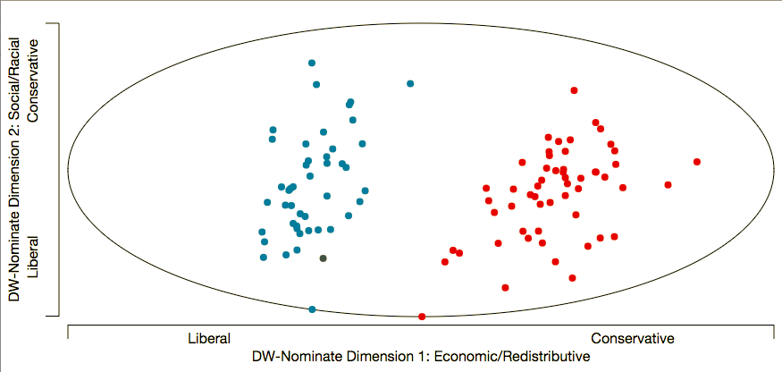

*Senate Ideology, 2015 - 2017*

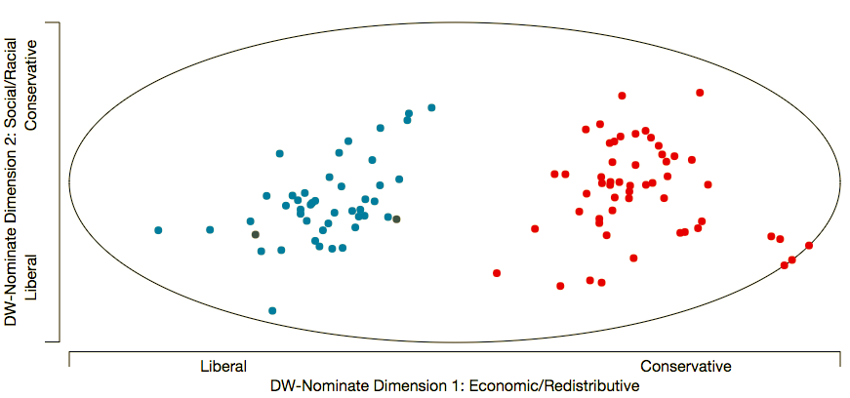

*House of Representatives Ideology, 2005 - 2007*

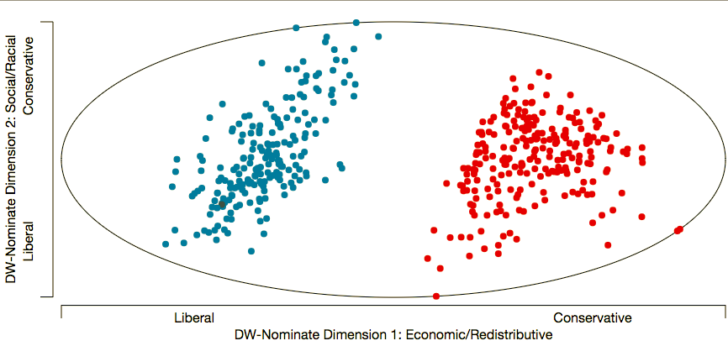

*House of Representatives Ideology, 2015 - 2017*

